Introductory GitHub Tutorial
© Duncan Rowland 26/1/2014 v1.1

Git is a distributed revision control and source code management (SCM) system. The GitHub Application for Windows/Mac software is a application that wraps much of Git’s functionality into an “easy to use” interface. You should note though that Git via the command line (e.g. clicking on “Git Shell”) allows access to more powerful features, but you should probably read a good book on Git first before you attempt to use it (http://git-scm.com/book). This workshop will concentrate on using the GUI application.

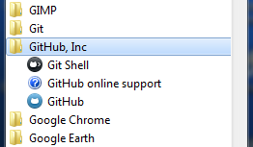
Locate the software as above

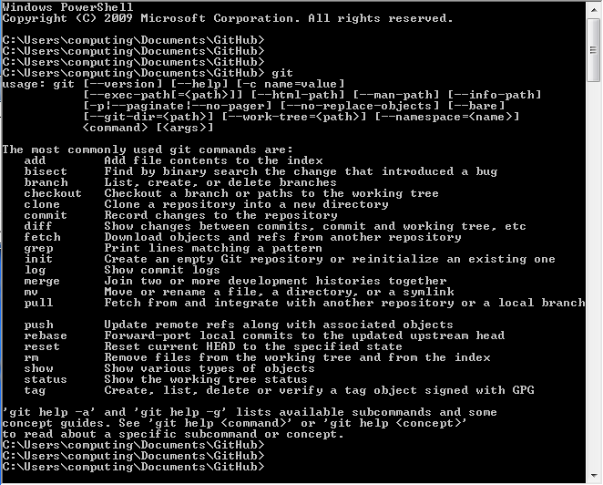
The command line is more powerful, but more complicated (some say).

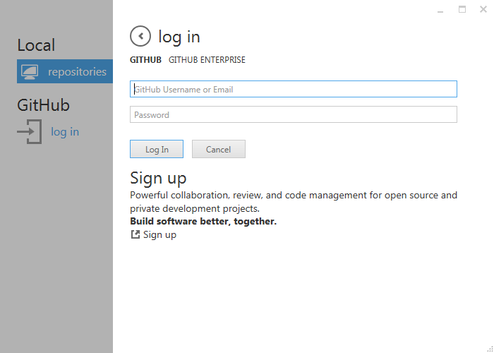
You do not need to login to github yet, the first part of this tutorial is about using Git locally (i.e. without a remote Git server). Just click the arrow next to “Log in” to skip.

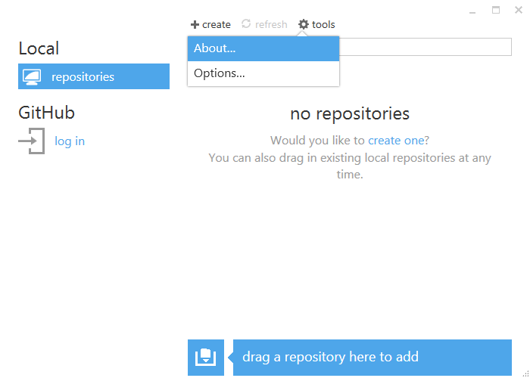
Click on “tools->About…” make sure your version is current.

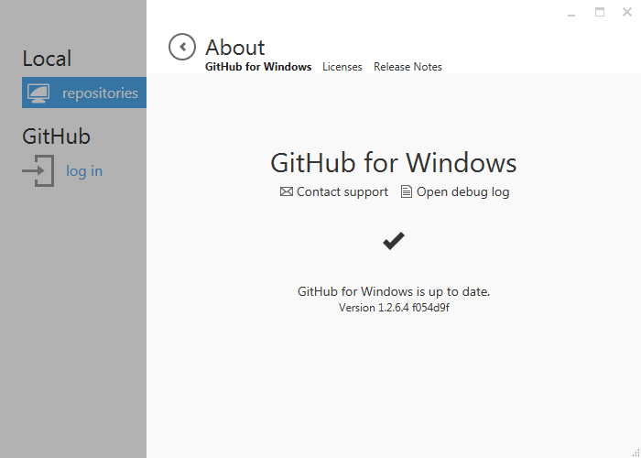
This tutorial was written using “Version 1.2.6.4 f054d9f”

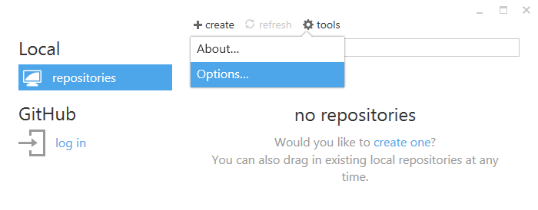Each time you start using Git on a shared machine you will need to setup the options.

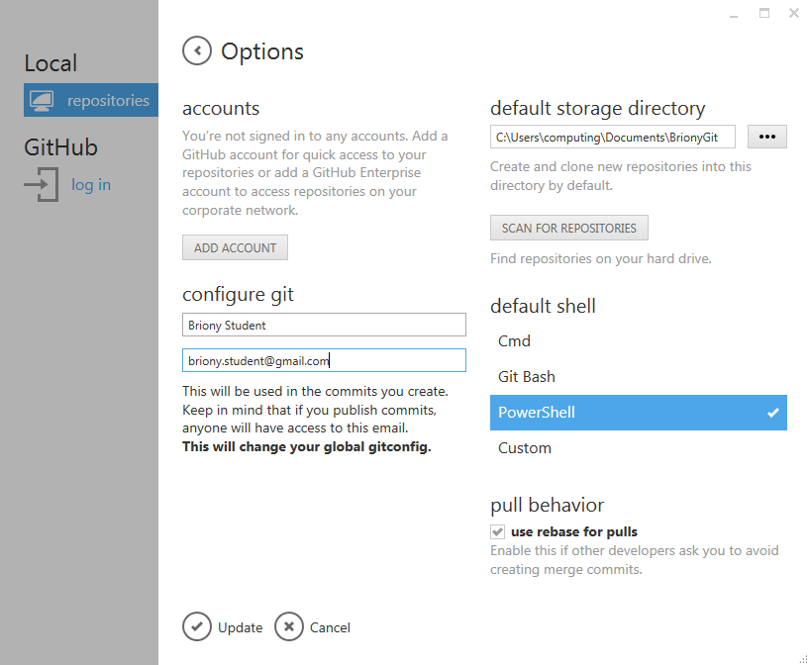
1) Enter your name, 2) Enter your email address, 3) Enter your storage directory.
N.B. this does not log you into the github website, it just sets details that will be linked to any changes that you make, and says where these changes will be stored.
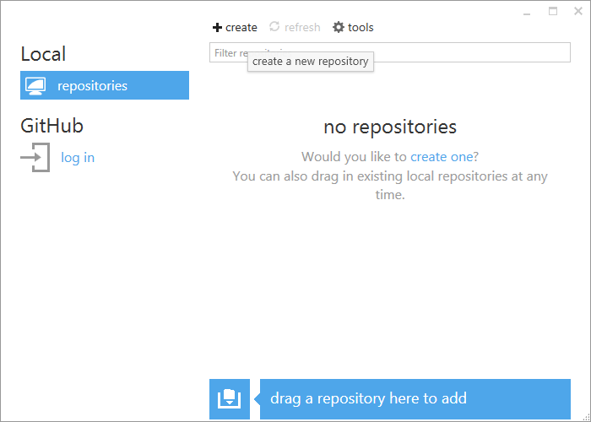
Click “+ create” to start making your new repository.

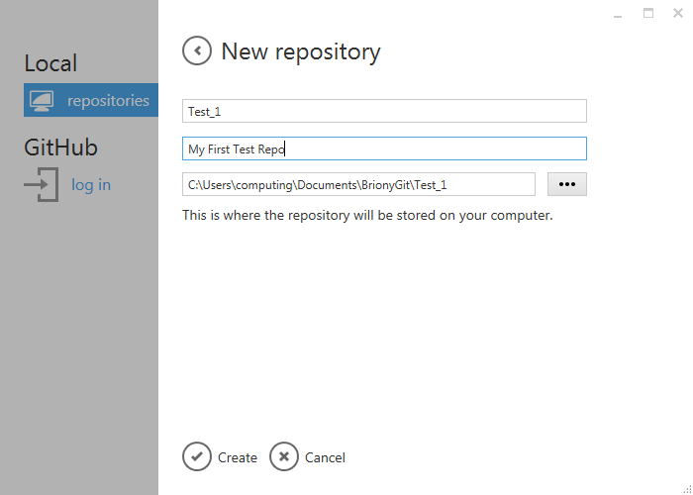
Type in a “Name” and a “Description” and click “Create”

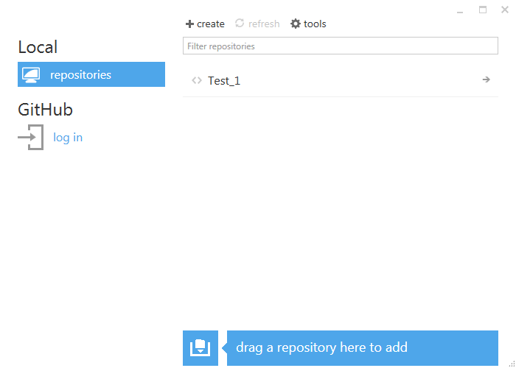
Now your new repo has been created.

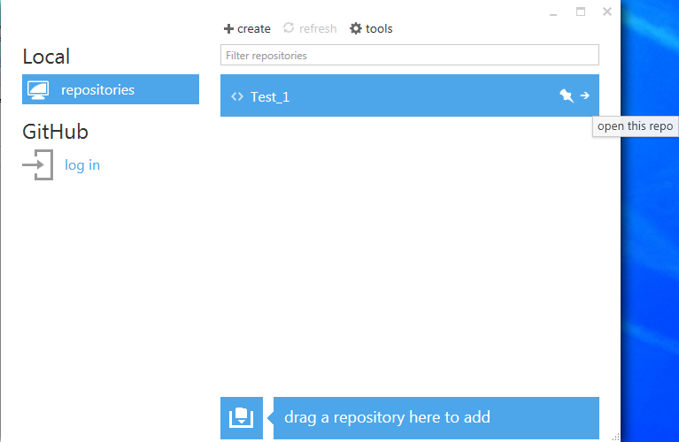
Click on the arrow and have a check to see the files that have been created.

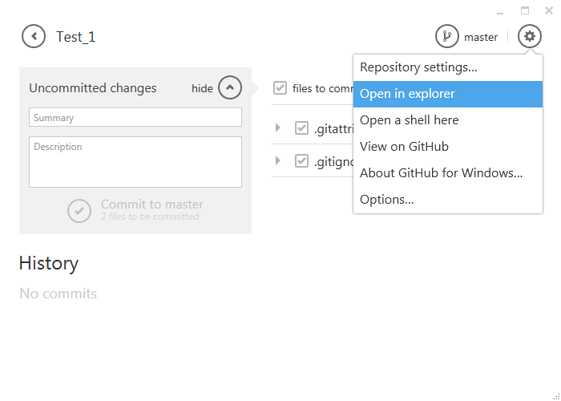There should be a folder called “Test_1” this is where all the files in your repo will be stored. You can open this folder from the “tools and options” menu (as above). At the moment it should just contain two text files “.Gitattributes” and ‘Gitignore” (whose names will be hidden in explorer). These contain the “Repository settings…” for this repo (and you can ignore these for now, though they will need changing when you start using Unity, to stop Git trying to keep track of everything).

Create a file that you want your repo to include. Use a text editor, e.g. Notepad to create a file in the “Test_1” folder called “readme.txt” and add the following content.

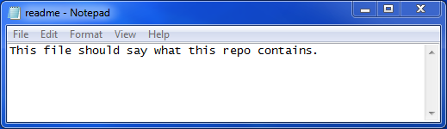

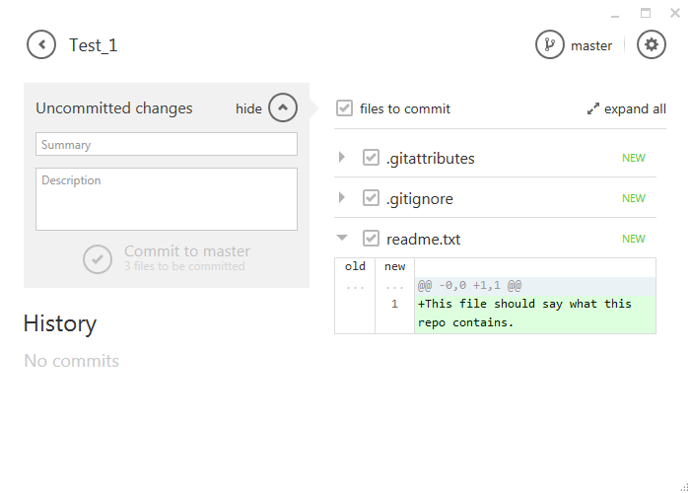
Go back to the repo and you should see the “readme.txt” file is now included. By clicking on the arrow near the file name you can see what changes have been made to the file. Even though this file is in the repo folder and it being tracked, it has not been “committed”, so if you deleted it, there would be no way to get it back. Let’s commit!

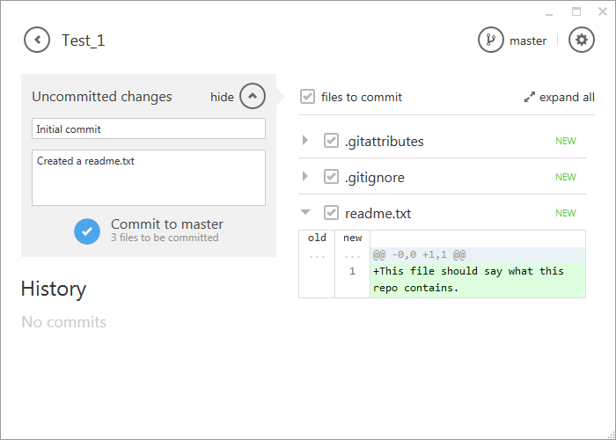
Enter a “Summary” and “Description” and click “Commit to master”.
For interest, all of the repository files will go into a hidden subfolder called “.git”, and the files you commit into the subfolders in “.git/objects/”. You can have a look at this database in various ways (e.g. the shell command “Get-ChildItem –force –recurse” will show you everything), and for reference, the encoded filenames are created using SHA1. But for now, let’s concentrate using the repo rather than how it works.

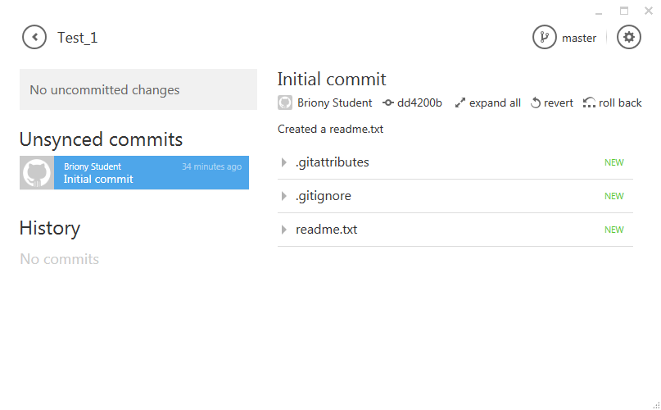
Note in the top-right corner is says “Master”. This means we are working what is know as the Master Branch and this is generally a bad idea. The Master Branch is reserved for completed work, i.e. work that has been tested and agreed by the development team for inclusion in the current build. When you download the latest changes (e.g. so that you can include you own work and prevent yourself from working with outdated code), you do not want to be downloading a load of bugs that break your project. So it is essential that when you are developing you create your own branches to develop with. These are often just copies of the Master Branch, but you can mess them up without having to worry about breaking the project for everyone else.

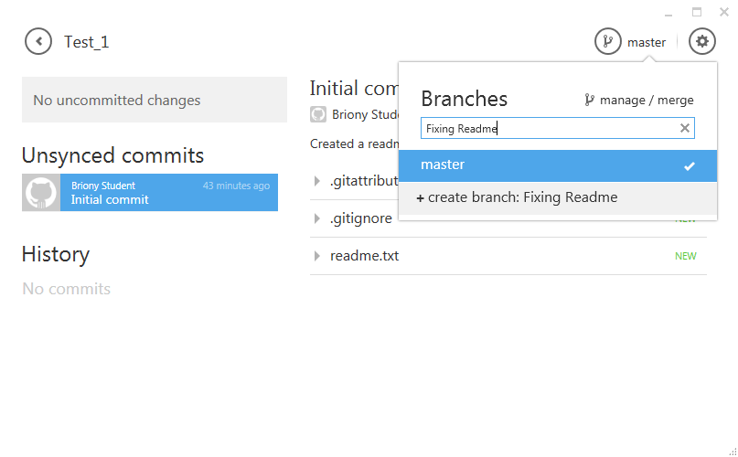
Create a new branch called “Fixing Readme”.

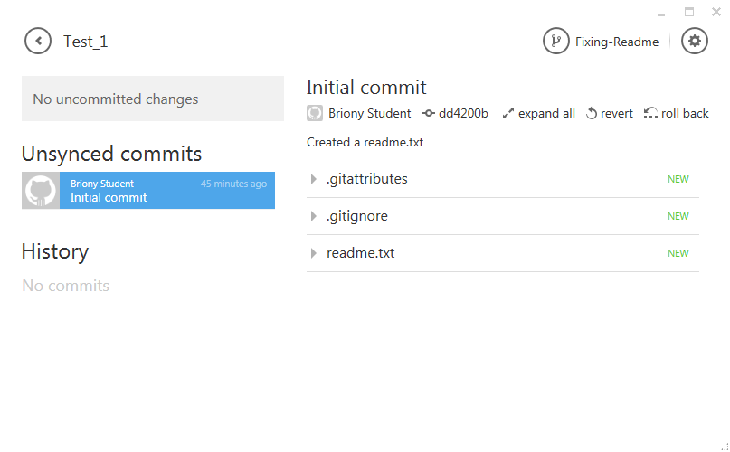
Notice how the current branch (top right) now says “Fixing-Readme”. Now we can make changes without worrying about breaking anything in the Master Branch
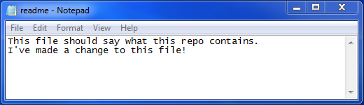
Open the file in Notepad and edit the text and save.

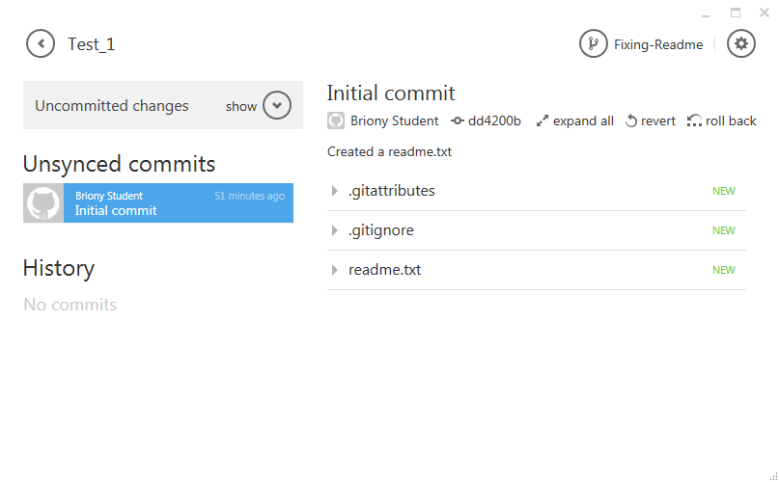
See that the application has now detected that some of your files have changed (it says, “Uncommitted changed in the top left). For interest, were you to now go into Notepad and undo your changes and re-save the file, then the application would detect that your file had gone back to its original state. It knows this because Git calculates the SHA1 from the contents of the file and uses it for the object’s filename. So, the same filename means the same contents (or at least it’s vanishingly unlikely that two files with the same SHA1 will contain something different to each other).
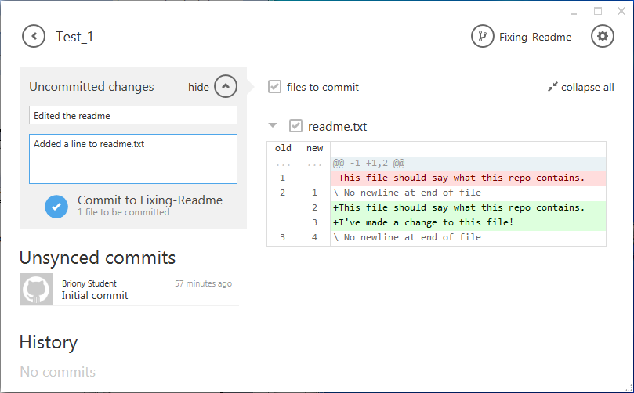
Enter a “Summary” and “Description” and click “Commit to Fixing-Readme”.
N.B. As before, if you do not commit your changes, they can be lost.

We should now have two committed branches, an original “Master Branch” and an edited “Fixing Readme” branch. You can change which branch the Test_1 folder currently contains (and which branch you would be working on if you made changes in that folder) by selecting the “switch branches” icon in the top right.

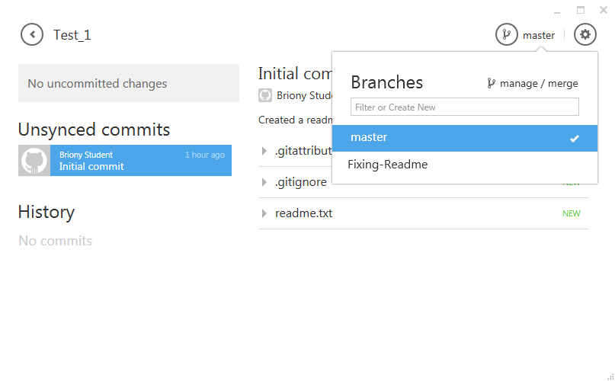
Try this:
- Select the master branch and open the readme.txt in Notepad
You should see the original (one line) contents.
- Close Notepad, select the “Fixing-Readme” branch and open the readme
You should see the edited (two line) version.
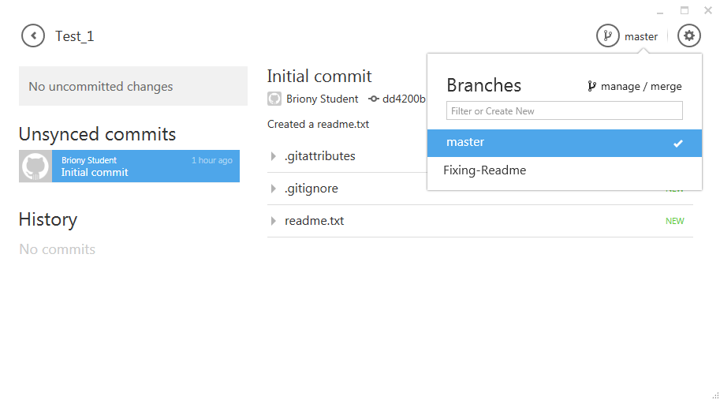
If you are happy with the changes you have made in your branch and would like to incorporate them into the master branch then you need to merge them. In the “switch branches” menu (top right), click on “manage / merge”.

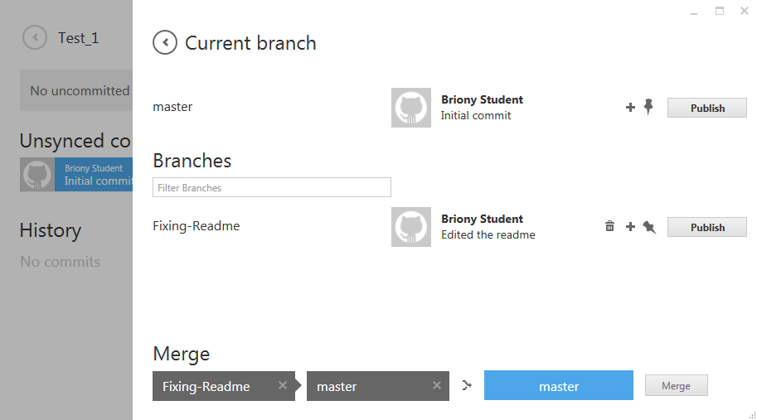
At the bottom, under where it says “Merge” drag the “Fixing-Readme” branch into the first box (i.e. the branch with the changes you want to add), and the “master” branch into the second box (i.e. the branch you want to make the changes to) and click “Merge”.
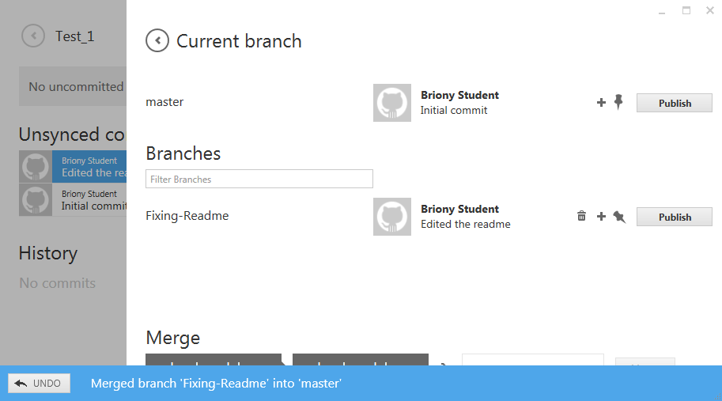
You should now find that the changes you made in your Fixing-Readme branch have been incorporated into the Master branch. You can check this by toggling between then two branches as before and checking the readme fine. This time there should be no difference between the branches.

Try this:
- Select the master branch and open the readme.txt in Notepad
You should now see the merged (two line) contents.
- Close Notepad, select the “Fixing-Readme” branch and open the readme
You should see the edited (two line) version.

You might now feel that you no longer need the “Fixing-Readme” branch. If you are confident that your changes have now been successfully made to the Master branch you can delete your temporary working branch by clicking the trashcan icon in the “manage / merge” panel. Just make sure that the temporary branch is not selected as the current branch, since you cannot delete that.

You can also try copying Test_1 folder (e.g. drag and drop in windows explorer to make “Test_1 – Copy”). This is an entire copy of your whole repository, i.e. includes all the changes that you have committed, as well as the current working branch. You can add this so it is tracked in the application by dragging in the copy.

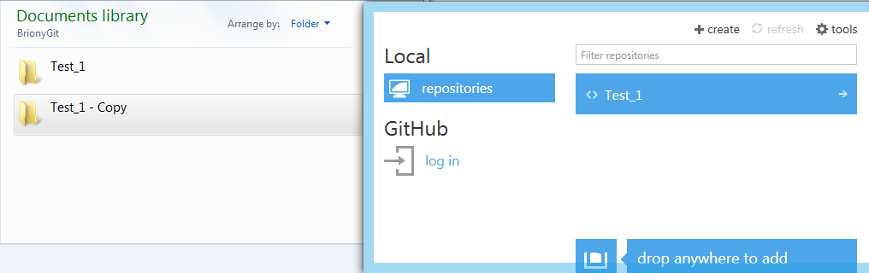
This is key to understanding how to work online with Git repositories. You can have multiple copies of the entire archive (each developer has one, and there is one at the github website). To collaborate then, you make your own copy of the repo, make some private branches, edit these, then merge these changes into a public branch (e.g. the master branch if everyone is happy with them, although other branches can be shared too) and then push the changes to shared branches up to the server where the rest of the team can get hold of them.

Lets add our Test_1 repo to the github server (remember, in effect this just means copying all the files from the Test_1 folder to github, though we let the application take care of the actual work).

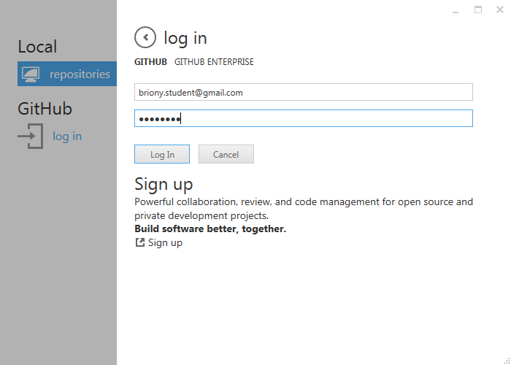
First, log into your own github account through the application. If you have not already made an account you will need to do so now.
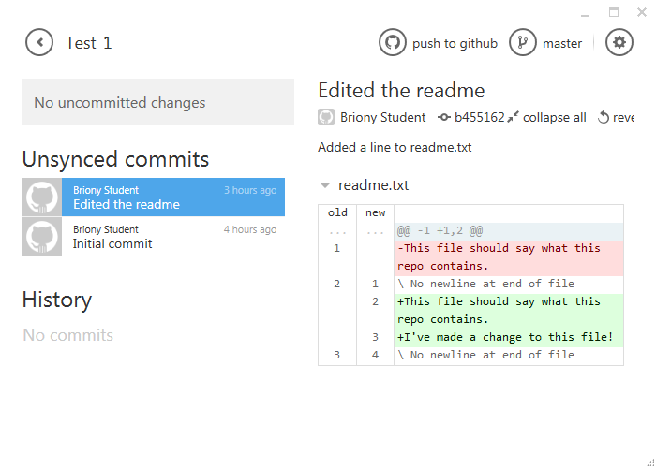
Open the local Test_1 repo and the click “push to github”

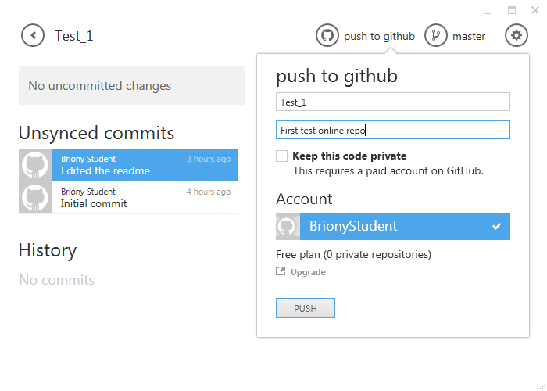
Enter a description and the click “PUSH”. This will create the repo on your github account, but in order to add the actual files, there is one more step…
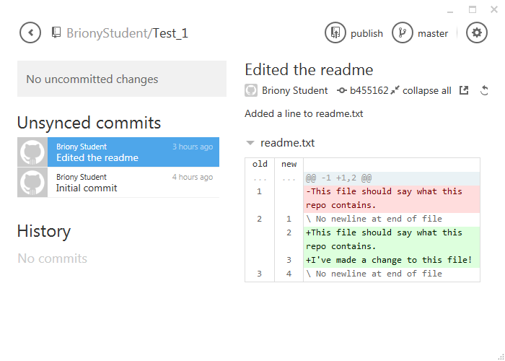
You need to “publish” the branches that you want to share. Some branches will just be for your own use, so there’s no need to publicly upload those, though you may want to keep a copy on Git for your own convenience. N.B. you should clearly always make a proper backup of your work somewhere else too, e.g. copies of the repo folder).

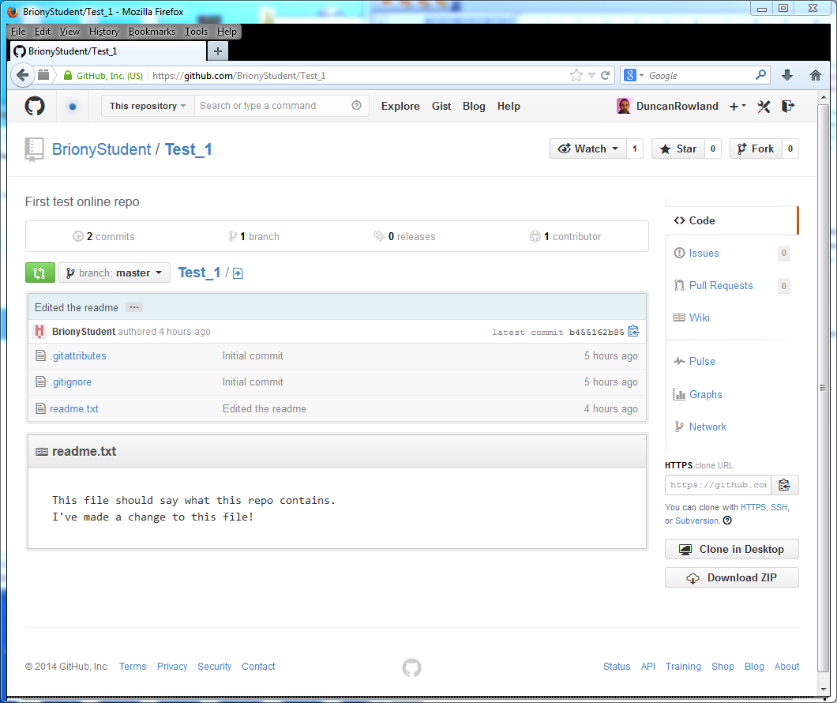
And that’s it. Your repo is up on github and other people can access it!
Now, log into the github website and take a look at your repo there.
Although anyone can download your work, this does not mean they can edit it. You must add people as “Collaborators” to your project so they can uploaded changes to it. In the following example, Briony will add me (“DrRowland”) as a collaborator and I will edit her readme.txt and upload it. Find a collaborator in the room and add them to your project (and have them add you to theirs) and follow along.

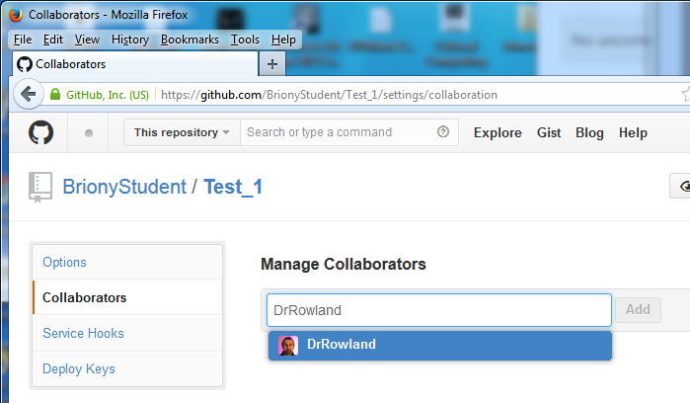
Open your own Test_1 repo on the github website and go to settings. On the left hand side click “Collaborators” and enter your collaborator’s details (not mine as above) in the box and click “Add”.

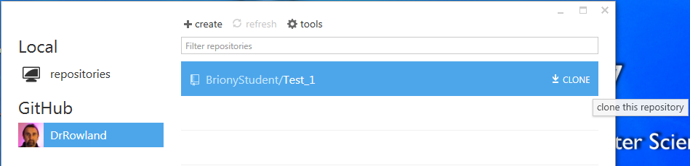

Back in github, it’s might be a good idea to go into “tools-Options” and change your “default storage directory” to something new (e.g. /BrionysRemoteGit). This is because in this tutorial BOTH of you will have a Test_1 repo so there is likely to be some confusion unless you keep them in separate folders.

Your collaborator should now clone your repository, and you should clone theirs.

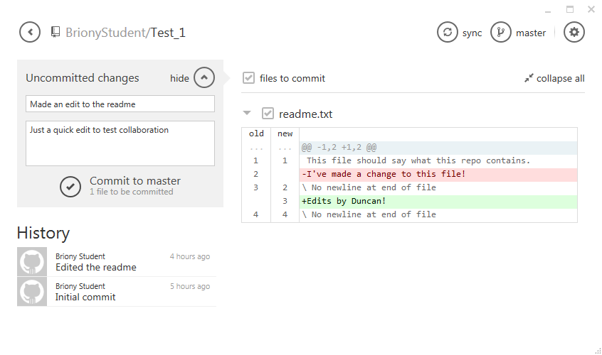
Once you have cloned your collaborators Test_1 repo you can make changes and commit them just like we did with our own repository.

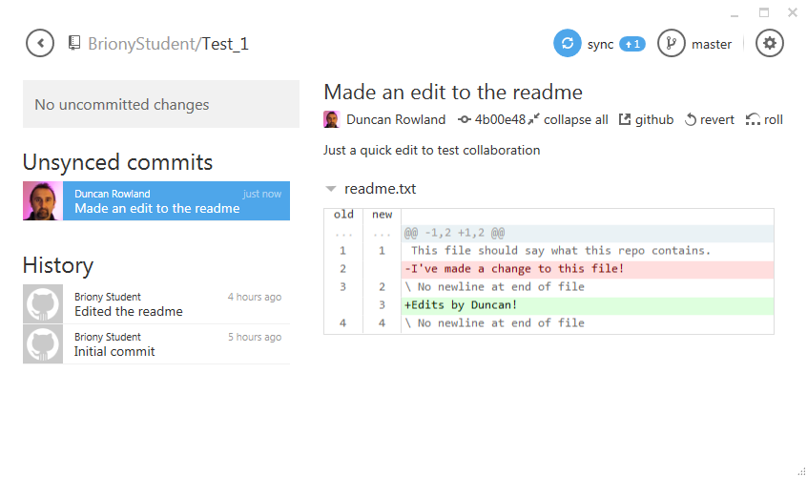
These will be stored locally until you sync the local changes with the server, at which point your changes will be uploaded. Make some changes to your collaborator’s readme file now and upload the changes as described.
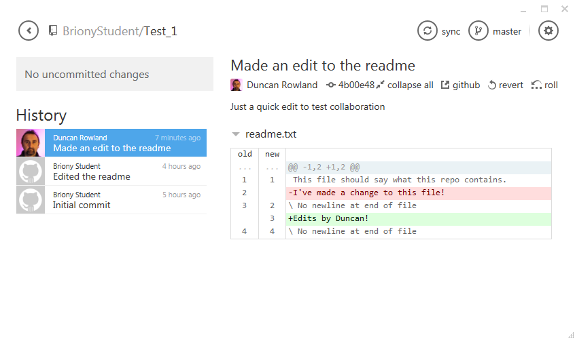
Duncan’s view of Briony’s repo (with all his changes uploaded).

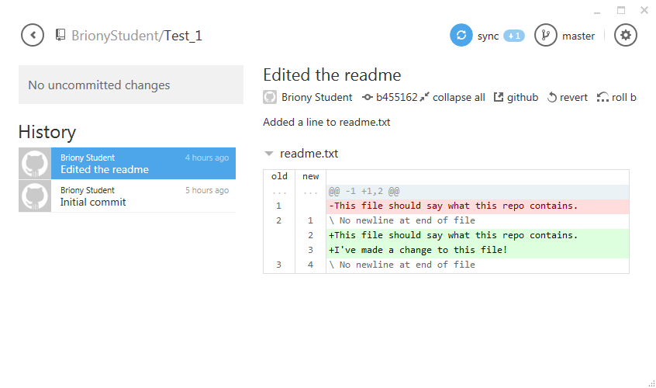
Briony’s view of her repo. N.B. she need to sync to download Duncan’s work.

It is important to keep your master branch synced so that you are not working with old code. You can always merge changes from the master branch into your local working branches (using a method similar way to that which merged your own changes into the master branch). N.B. When you’ve merged your changes with the master branch make sure it’s properly tested before you sync and uploaded it (otherwise you will break the master branch for everyone).

Your task now, until the end of the workshop, is to try using Git with your collaborator until you are confident with it. This will be your last opportunity to become familiar with it before we use it in the project.

N.B. Excuses along the lines of “I did loads of work but then I tried checking it into git and I somehow managed to loose everything” are NOT ACCEPTABLE! You should ALWAYS BACKUP YOUR WORK. Git is a collaboration and versioning tool and it not an alternative method for creating backups.

Try the following:

- Choose a repo to work with (either yours or your collaborators)
- Have one of you add another text file to it (i.e. commit and sync)
- Make sure you're collaborator also syncs (so they receive the new file)
- Now, both make some changes to the new file at the same time
- Finally both try and check in your changes at the same time

What happens? - how can you fix this?

- Try adding a new image file and doing the same thing (steps 3-5 again)

What happens now? - and how can you fix this?

- Mouse over 'revert' and 'rollback'

Can you see the different between the two? (it's not quite as obvious as it looks)

- Test using 'revert'
- Test using 'rollback'
- Add BrionyStudent as a collaborator to one of your repos

Adding Briony as a collaborator is important, I will use this account to login and check your work. I will also use this to make a list of your github accounts.

- Continue to test git for the remainder of the session (finish 1pm)

p.s. Last year there was some trouble using Unity with git (with people attempting to upload and download gigabytes of files that Unity created). In general, you should not be uploading files that get created for you (i.e. 'automatically' by your development system), rather you should be uploading just your actual 'work'. To cause this to happen you need to to do two things, tell git to ignore some files (i.e. not copy them to the repo) and to configure Unity so that it does not make others in the first place. Andy and Oliver have been looking into this and apparently the solution appears here:

http://www.dannygoodayle.com/2013/02/14/using-unity-with-git

If you have time at the end of the session and are confident with git and Unity I recommend creating a test Unity repo in preparation for the development work.

You can stop the application from tracking the copy of Test_1 (“Test_1 – Copy”) by right clicking on it’s title and selecting (“Stop tracking repository”). This will leave the files intact, so you can also delete the “Test_1 – Copy” folder if you want too, leaving just the original “Test_1” files.

